Introduction: The Reader and Sam Owen Fire Department are working together to provide the reader with real life actionable fire and highway safety information. Here is the next installment. Sam Owen Fire Department is located in Hope, Idaho. It is one of many local volunteer fire departments in our area. If there is a subject you would like us to cover, please email the author at twendle55@gmail.com.
A 4th of July Tradition
By Todd Wendle - Sam Owen Fire Department (Hope Idaho)
Photos: Todd Wendle
10:45 AM (a few days before the 4th)
"Hey Honey, do you want to go up to Bonners with me? I heard there is an awesome fireworks stand up there. We can get lunch too. I've never done any fireworks. You?
"Yes, that sounds great! But do you really think you know what you are doing? I have heard a lot of stories of fires, maiming, and even death! I do not want to be on the front page of the newspaper!"
"Nonsense! I have watched two or three YouTube videos. They aren't that dangerous. Light the fuse and get back. That is it. Get your coat and purse and let's go."
10:05 PM - You know dear, I think we should just try one of these! Then we will know what to do the 4th!!! Yeah let's give one of these babies going! You have a match??
10:10 PM - "911, what is your emergency?"
"Please help!!! My husband just lit something called "Night Thunder"!! It tipped over, exploded! My husband is hurt AND our back woods are on fire!! Can you send some help this way?!?!Please!!!! Hurry!!!! "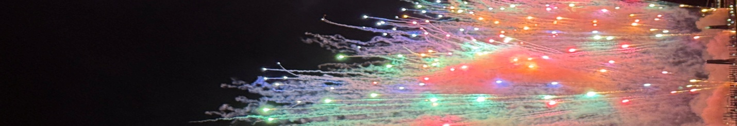
10:11 PM - The call went out and Bonner County EMS and Sam Owen Fire responded. Quick response and lots of water later, the nearby homes were safe, smoldering blackened trees and the smell of smoke filled the night air. Luckily the husband escaped with a burned hand and a bruised ego.
Without the quick response and a little wind, it all could have been much worse. If he would have just listened, he could have said, "We can go down to Memorial Field and watch the fireworks." And instead of a burnt hand and a blackened back yard, they both could be sipping a glass of wine under a North Idaho sunset on their back porch.
So.... how do we proceed this coming 4th of July?
By far, the easiest thing to do is to not buy any aerial fireworks.
In the Sam Owen Fire Department and in the state of Idaho, it is illegal to use aerial fireworks.
They have been made illegal for several reasons.
They are inherently dangerous. Both to the person and the place. Here are some statistics to ponder.
- There were nine deaths and 9700 injuries just in the US in 2023
- There were 31,302 fires started by fireworks at a cost of 109 million in 2022 (National Fire Protection Association)
- Most injuries come from firecrackers, sparklers, and bottle rockets
- Adolescents have the highest rate of injury. (go figure)
- Thousands of pets go missing during 4th of July fireworks.
Second best? If you are hell bent on doing fireworks on the 4th of July, be safe about it. Don't say something like "That wouldn't happen to me!" and become another tick in the statistics above.
- Have water ready, both with the hose, and with a bucket of water for the spent fireworks.
- READ the directions. They are most helpful, especially if you read them BEFORE you decide to light the fuse.
- Point them AWAY from people and ANYTHING flammable. (Like your tree filled backyard)
- Adult supervision is a must (sober adult supervision that is)
- Alcohol and fireworks do NOT mix well
- ALWAYS BE CAREFUL. Those are explosives in your hands and pointed upward towards your eyes.
I know, from past experiences, that "it cannot happen to me!" But it most certainly did. And it will to you as well.
Give it some thought this year. Hope fireworks are spectacular from the water. Get in your boat, or find someone else with a boat and take it in. There is nothing like it!
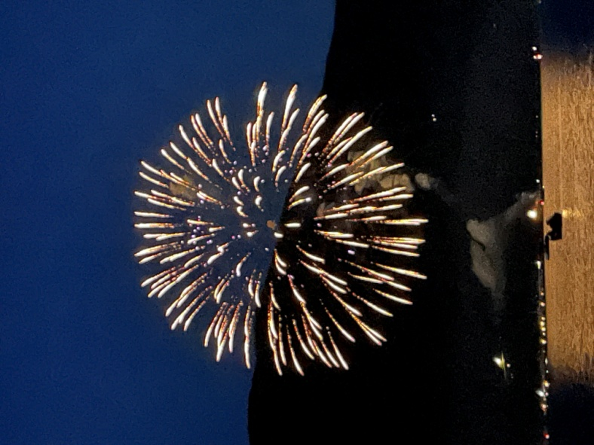
There are many displays to choose from locally. Bayview, Sandpoint, CDA, you name the city, they are probably going to have a fireworks display. Grab the blanket, the cooler, and a couple of lawn chairs and head out and enjoy the celebration of our country.
And maybe more importantly, there will be no trip to the hospital and you do not burn your house or a neighbor's to the ground or the woods around you.
Remember, IF it cannot happen, it will not. Be careful out there.

